**Week 3 ADA LAB**

**27-06-2023**

**Name: YAPARA KARTHIKEYA**

**1BM21CS249**

**Topological Sort**

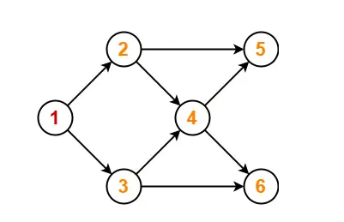

**Code:-**

#include<stdio.h>

#include<conio.h>

int a[10][10],vis[10],E[10],n,J=0;

void dfs(int v);

void main(){

int m,c,d;

printf("Enter the number of vertices");

scanf("%d",&n);

for(int i=1;i<=n;i++){

for(int j=0;j<=n;j++){

a[i][j]=0;

}

}

printf("Enter the number of edges");

scanf("%d",&m);

for(int i=1;i<=m;i++){

printf("Enter the edges");

scanf("%d%d",&c,&d);

a[c][d]=1;

}

for(int i=1;i<=n;i++){

if(vis[i]==0){

dfs(i);

}

}

printf("Topological Order\n");

for(int i=n-1;i>=0;i--){

printf("%d\t",E[i]);

}

}

void dfs(int v){

vis[v]=1;

for(int i=1;i<=n;i++){

if(a[v][i]==1 && vis[i]==0){

dfs(i);

}

}

E[J++]=v;

}

**Output:-**

